**EXPERIMENT-21**

**DATE;04-10-2025**

**AIM;** Demonstrate Platform as a Service (PaaS) create and configure a new VM Image in any Public Cloud Service Provider using Azure.

**PROCEDURE;**

**STEP1:** FIRSTLY, GO TO APPSERVICE TO CREATE AN WEBAPP.

**STEP2:** ENTER THE RESOURCE GROUPAND WEBAPP NAME AND REGIONAND SELECT THE LINUX OS.

**STEP3**: AFTER ENTER THE ALL THE NECESSARY THINGS CLICK THE REVIEW AND CREATE AND CLICK THE CREATE THE WEB APP.

**STEP4:** AND OUR DEPLOYMENT IS COMPLETED.

**STEP5:** GOTO WEBSITE URL LINK STEP6: THIS IS OUR WEBAPP SERVICE.

**IMPLEMENTATION;**

**OUTPUT;**

**STEP1:** FIRSTLY, GO TO APPSERVICE TO CREATE AN WEBAPP.

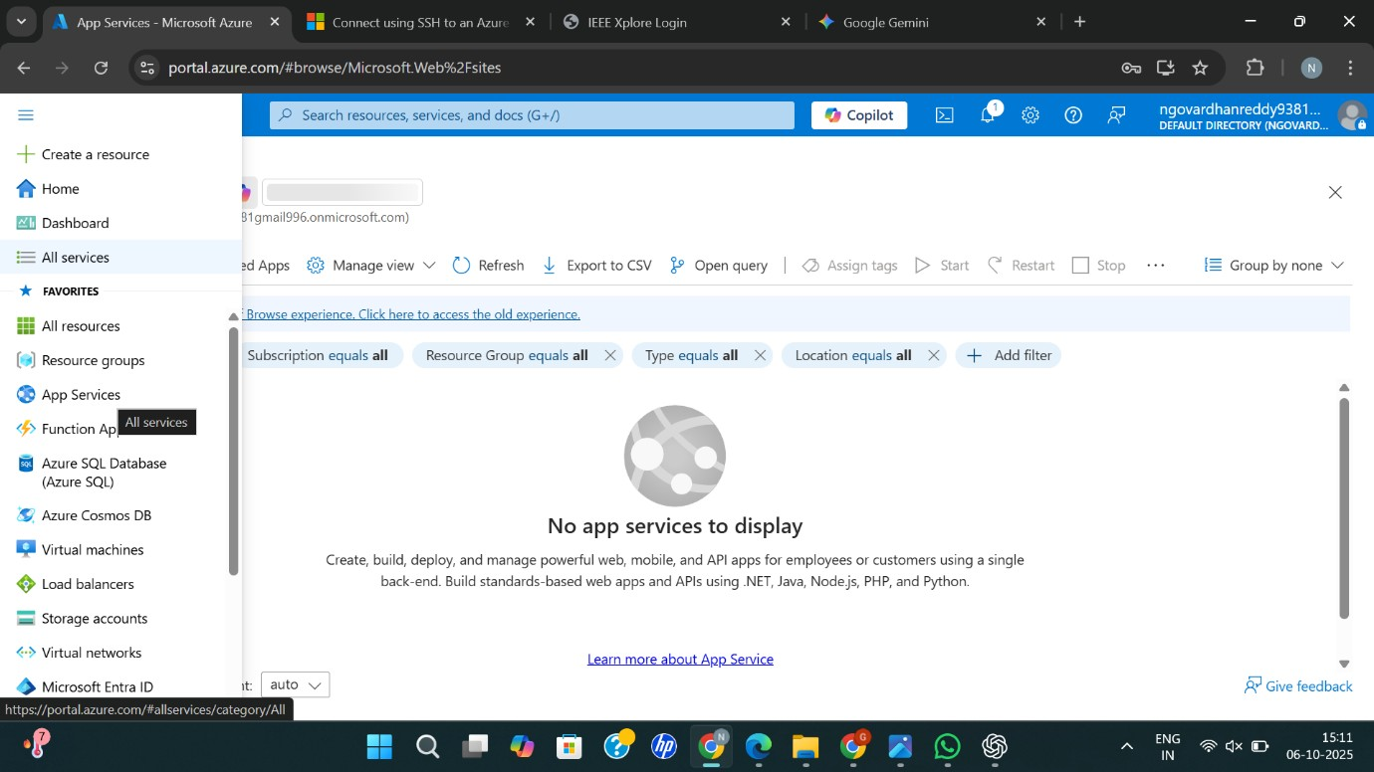

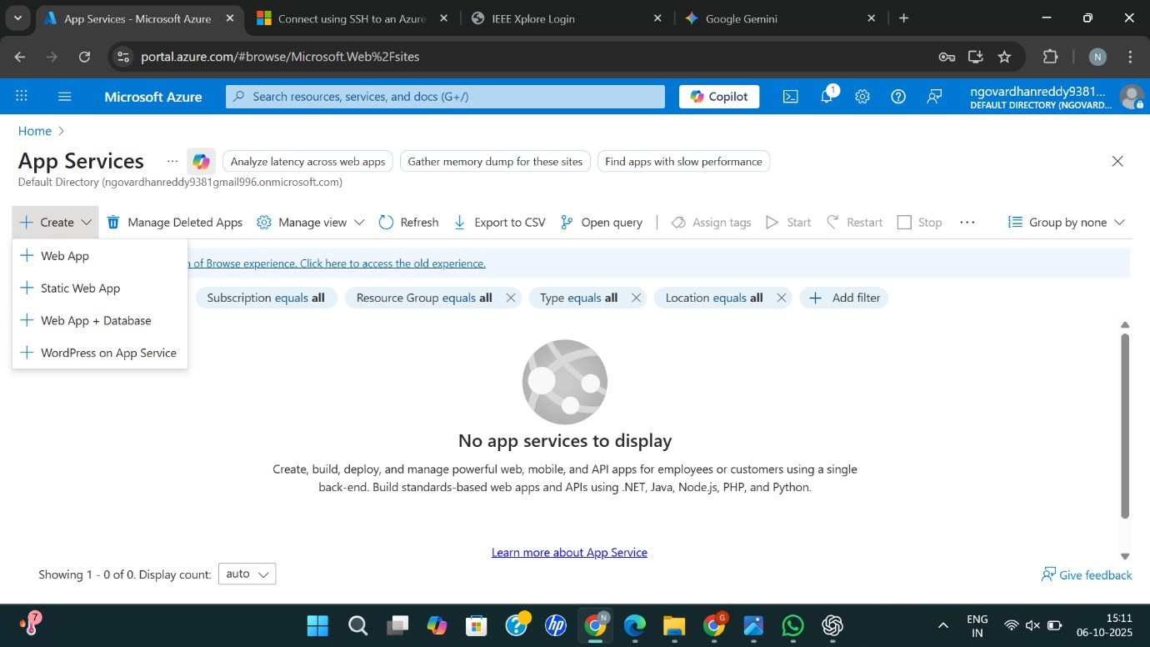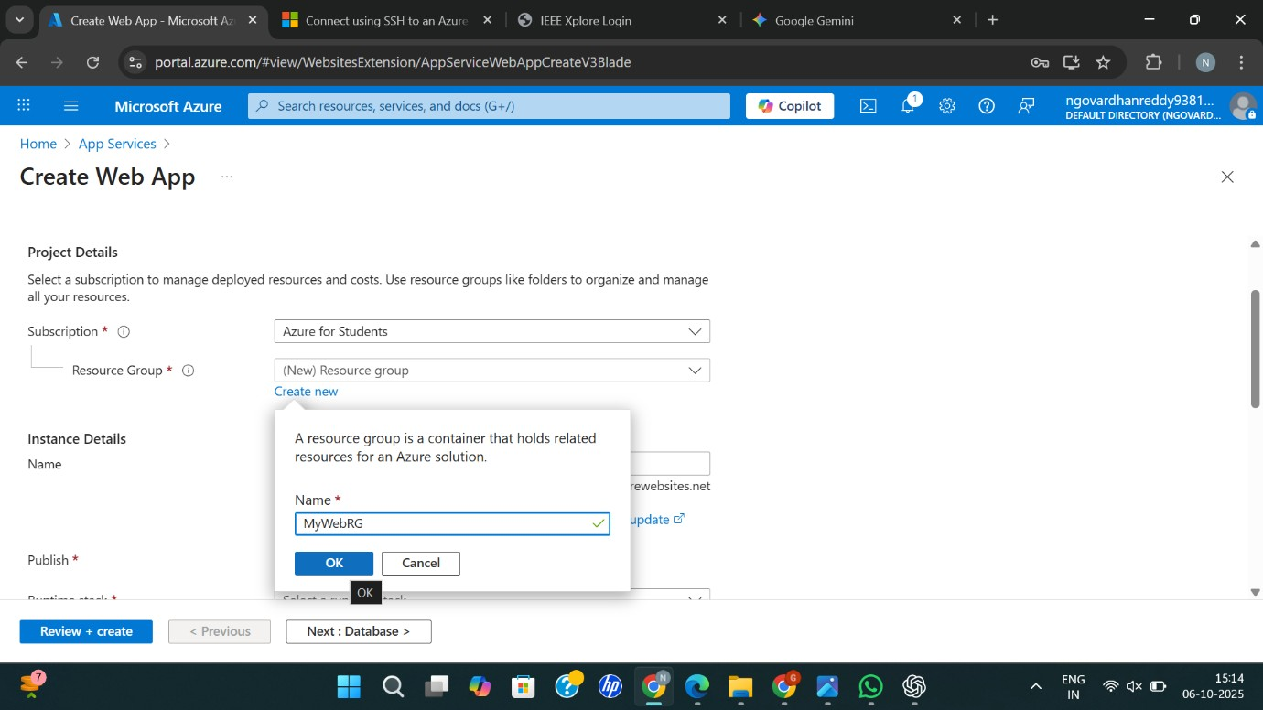

**STEP2:** ENTER THE RESOURCE GROUPAND WEBAPP NAME AND REGIONAND SELECT THE LINUX OS.

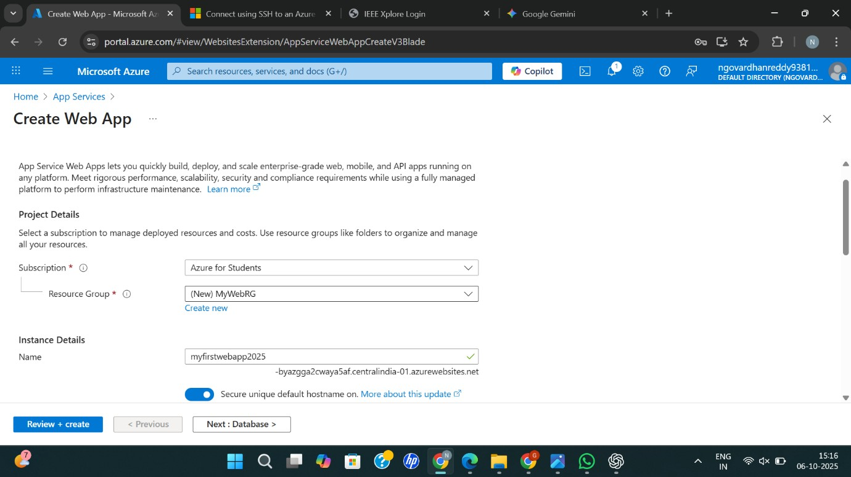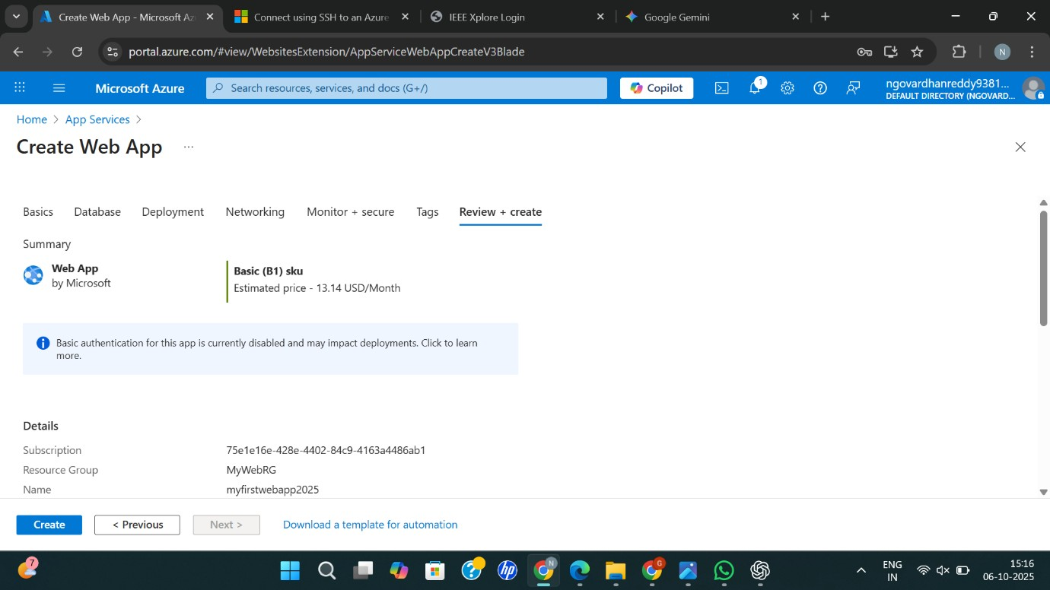

**STEP3**: AFTER ENTER THE ALL THE NECESSARY THINGS CLICK THEREVIEWAND CREATE AND CLICK THE CREATE THE WEB APP.

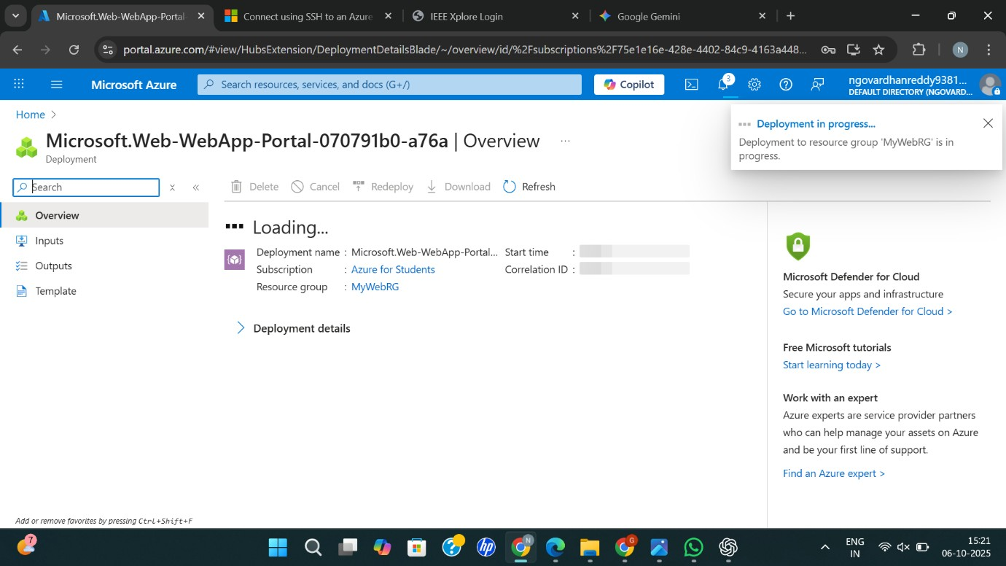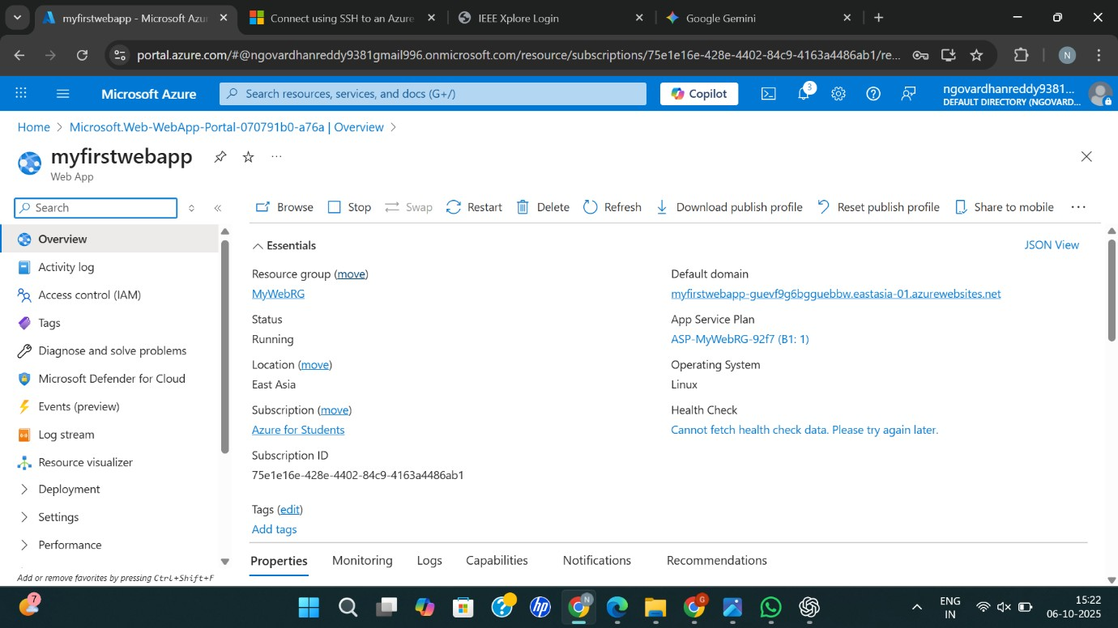

**STEP4:** AND OUR DEPLOYMENT IS COMPLETED.

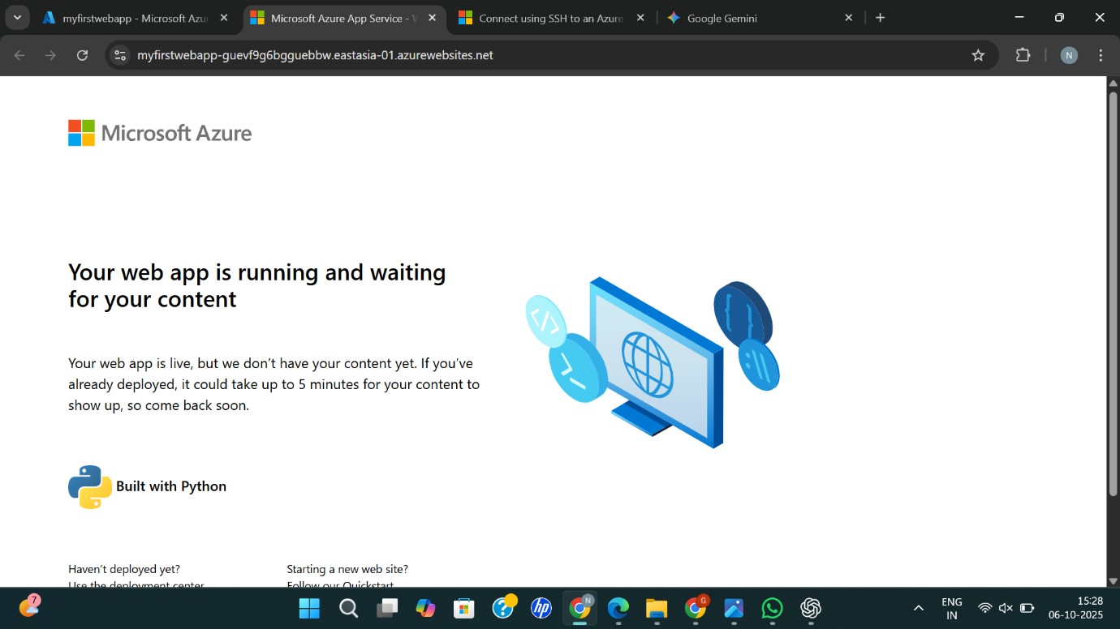

**RESULT:** Successfully Created a simple web site using any public cloud service provider (azure/gcp/aws) and check the public accessibility of the stored file to demonstrate storage as a service